Expleo Onboarding

|  |  |  |  |
| --- | --- | --- | --- |
| **Version** | **Comments** | **Date** | **Name** |
| V1.0 | Initial Draft | 6th April 2020 | Rajeev Kumar |
|  |  |  |  |

* Expleo Onboarding application has seven tabs

1. Home
2. Personal
3. Education
4. Experience
5. Family
6. Professional Reference
7. Other

* Micro Services we have need to develop.
* *Method: Post/Put (create/update)*

1. Login -Navigation to home
2. Personal
3. Education (Single / Multiple record)
4. Experience (Single / Multiple record)
5. Family
6. Professional Reference
7. Other

* *Method: Get*

1. Review All Details for candidate
2. Get list of all candidate for Admin
3. Get list of all candidate with filter option for admin

* *Method: Delete*

1. Admin can delete candidate record ( Single / Multiple record )

* Wireframes:
* Login page for admin users

{TBD}

* Home Page for New Joiner

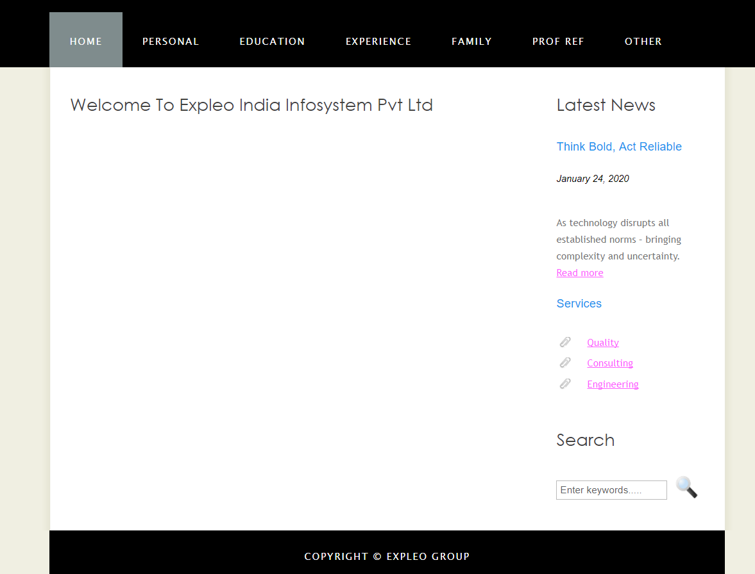

* Personal Information

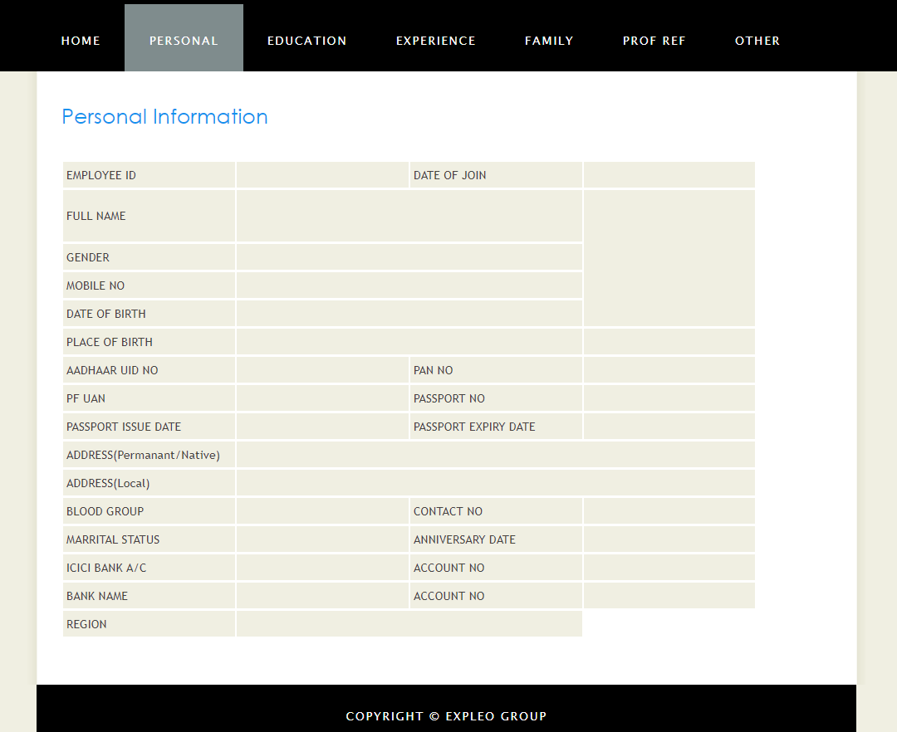

* Education Records

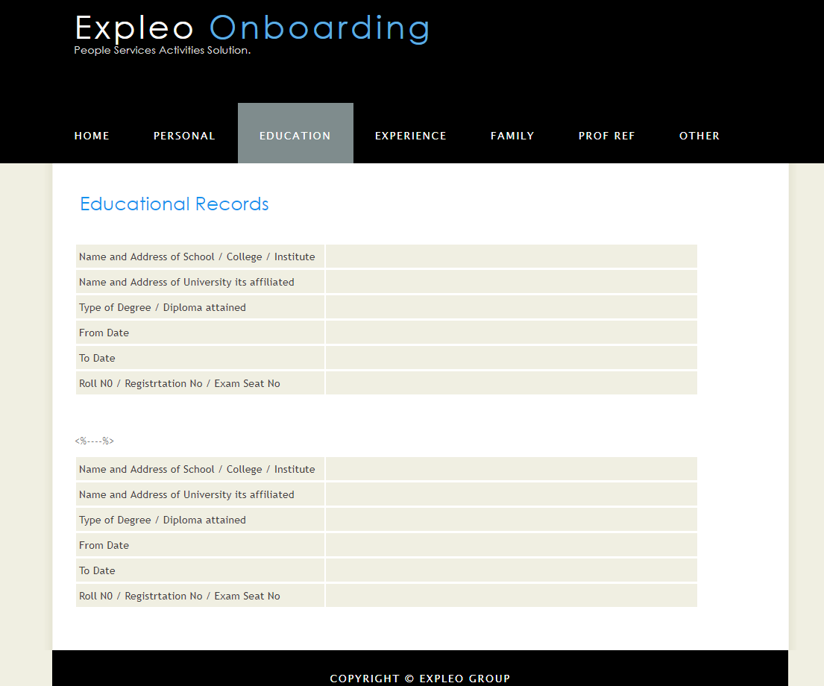

* Experience Page

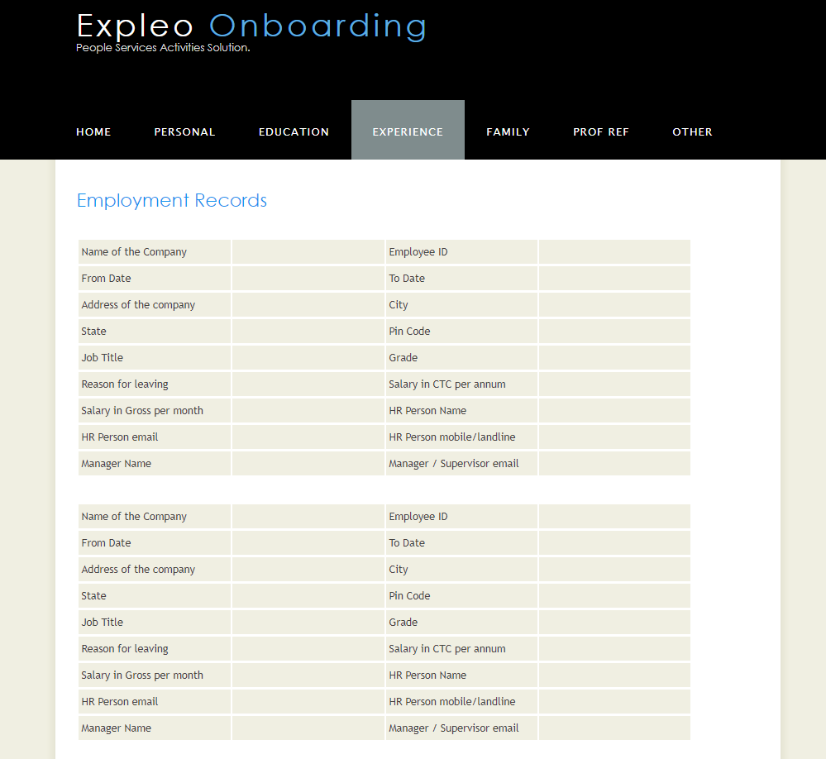

* Family Page

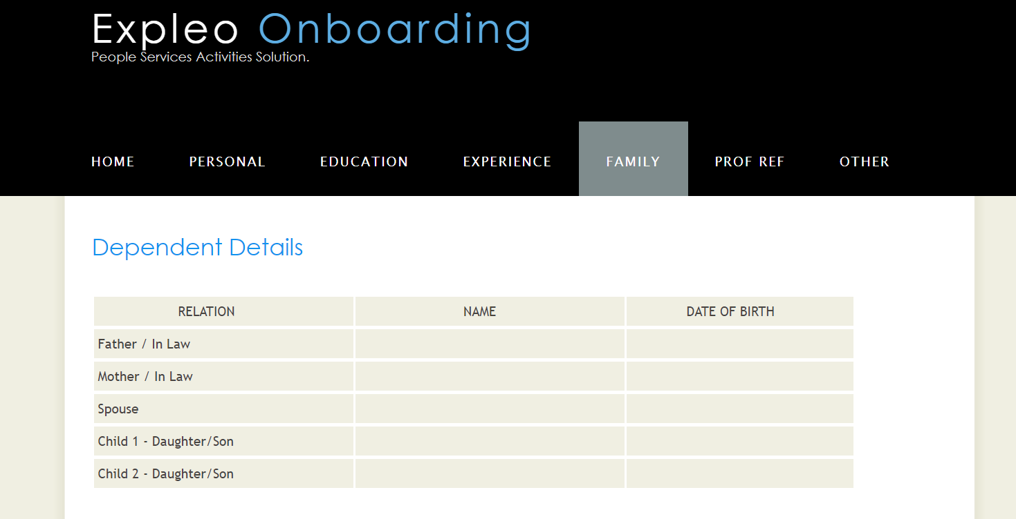

* Professional Reference Details

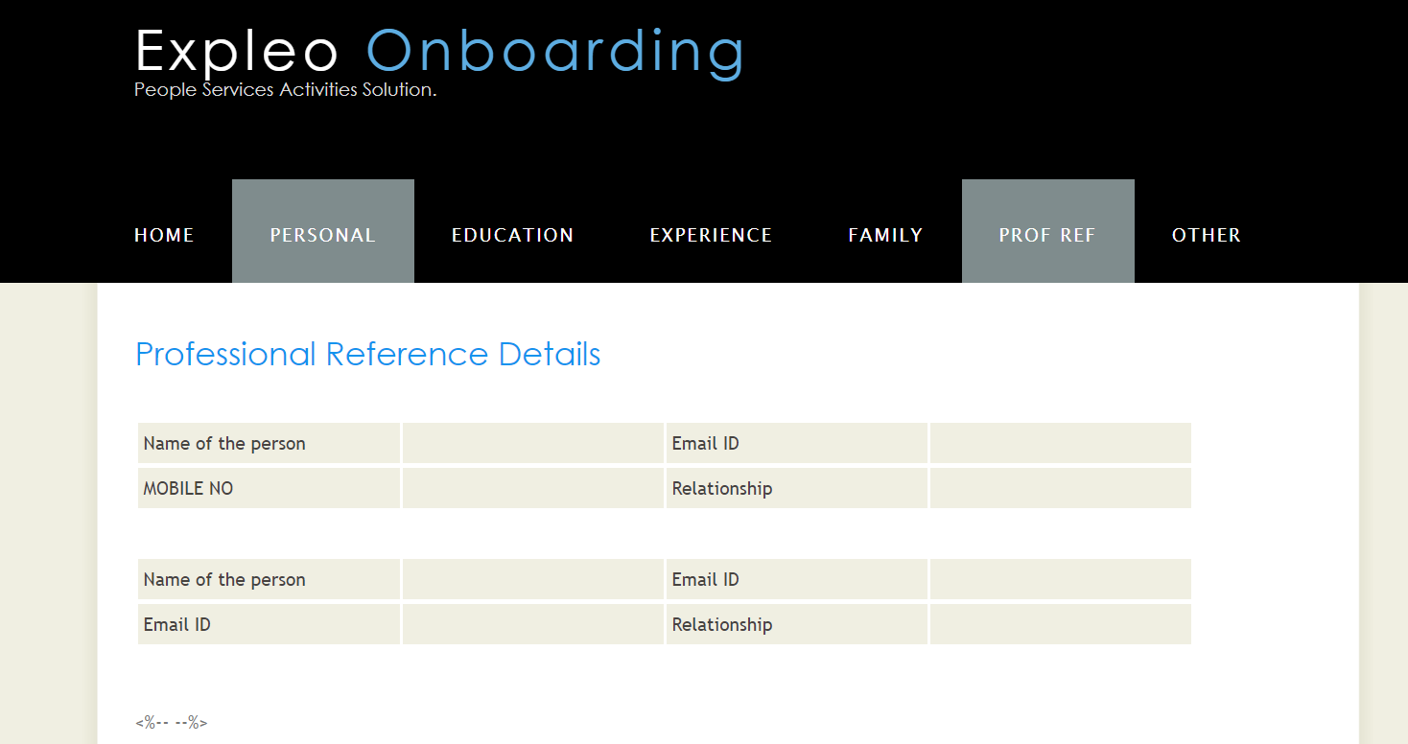

* Other page

